Olympic Windsock Project
We are going to be making an “Olympic Windsock” to go along with our reading story this week. At school, we are going to be making the top of the windsock. At home, you are going to be making the parts that hang off the bottom of the windsock. I have given each student 4 pieces of paper. You will use these to design the bottom of your windsock.
**Each Piece Of White Paper Needs:** (15 points per piece)
- The name of an event that is done in the Olympics (5 pts)
  - Ex. Swimming – 100 Meter Butterfly
- A picture of the event (5 pts)
  - Drawn or printed off the computer
- The name of someone who has participated in that event (5pts)
  - Ex. Michael Phelps
Here is an example of what the piece of paper could look like.
Swimming - 100 Meter Butterfly

Michael Phelps

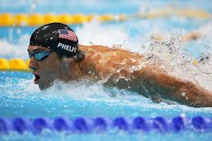

**Due: Friday, August 30th**
This will be worth a total of 60 points.

